INSTRUCTIONS FOR AUTHORS OF PAPERS (MAIN HEADING FONT: CALIBRI 11 BOLD UPPERCASE)
(2 lines)

Author full name 1, Author full name 2 & Author full name 3

(2 lines)
ABSTRACT
Purpose:
Design/Methodology/Approach:
Findings:
Originality/Value:

(2 lines)
KEYWORDS: maximum 6 key words.
(1 line)
- INTRODUCTION (font: Calibri 11 bold all uppercase)
This paper provides instructions for the preparation of papers for the Conference SSC2015 with Microsoft Word. Please follow the guidelines herein when preparing your paper. Failure to do so will result in a paper being rejected, returned for appropriate revision, or edited without your knowledge. Do not include the abstract in the full paper.
The page size for the Word processing is A4 (297 x 210 mm). The total length of the paper must be not more than 9 pages. UK English should be used throughout the paper. Throughout the paper authors must use Calibri font, 11-point font size. The paper should be single spaced. Do not use other fonts; use of other fonts means the proceedings editors will need to send the paper back to you to change the font. The text area layout is as shown in these pages. This document is formatted as described within. Left and right margins set at 2.5 cm, top and bottom margins set at 2.5 cm. For new paragraph indent the first line by 0.4cm.
- line)
- HEADINGS, ACKNOWLEDGEMENTS, REFERENCES, KEYWORDS
Headings of sections, subsections, and sub-subsections should be left-justified, set in the bold font style, and numbered as shown in this document. The headings for the Acknowledgments, References and Keywords are not numbered. Section headings should be set in FULL UPPERCASE LIKE THIS PHRASE, while subsection and sub-subsection headings should be Capitalized in Headline Style like This Phrase. Insert one blank line before and after each heading. Do not include page numbers these are generated by the proceedings editors.

- FORMATTING PAGES
  - Mathematical Expressions in Text and in Displays
Display only the most important equations, and number only the displayed equations that are explicitly referenced in the text. To conserve space, simple mathematical expressions such as may be incorporated into the text. Mathematical expressions that are more complicated should be referenced in the text, then enclose the equation number in parentheses (1) and place it flush with the right-hand margin. For example, the quadratic equation has the general form (1)

3.2 Figures and Tables
Figures and Tables should be centred within the text and should not extend beyond the right and left margins of the paper. Figures and Tables should be readable. Figures and Tables are numbered sequentially, but separately, using Arabic numerals. Each Table should appear in the document after the paragraph in which the table is first referenced [as shown in Table 2].

Table 2: Counting in Bulgarian

English | Bulgarian
one | Edno
two | Dve

Each Figure should appear in the document after the paragraph in which the Figure is first referenced. Figure captions appear below the Figure [as shown in Figure 4]. Captions for Figures or Tables should be centred.
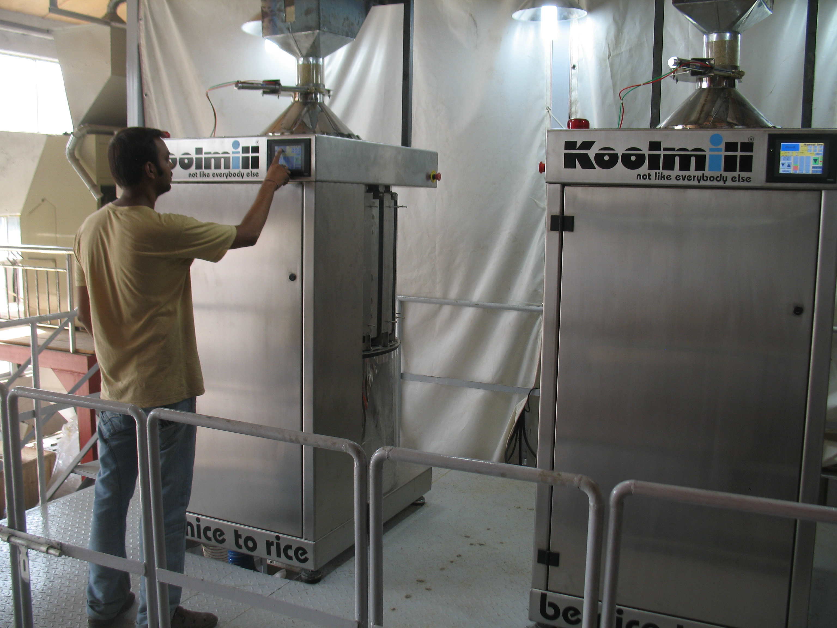

Figure 4: Title

3.3 Citing a Reference
To cite a reference in the text, use the author-date method. Thus, Chien (1989) could also be cited parenthetically (Chien 1989). For a work by more than three authors, use an abbreviated form. For example, a work by Banks, Carson, Nelson and Nicol would be cited in one of the following ways: Banks et al. (2000) or (Banks et al. 2000).

3.4 List of References
The section heading is REFERENCES. List only references that are cited in the text. Arrange the references in alphabetical order. Give complete references without abbreviations. To identify multiple references by the same authors and year, append a lower case letter to the year of publication; for example, 1984a and 1984b.

REFERENCES
Banks, J., J. S. Carson, B. L. Nelson, and D. M. Nicol. 2000. Discrete-event system simulation. 3rd ed. Upper Saddle River, New Jersey: Prentice-Hall, Inc.
Cheng, R. C. H. 1994. Selecting input models. In Proceedings of the 1994 Winter Simulation Conference, ed. J. D. Tew, S. Manivannan, D. A. Sadowski, and A. F. Seila, 184–191. Piscataway, New Jersey: Institute of Electrical and Electronics Engineers, Inc.
Chien, C. 1989. Small sample theory for steady state confidence intervals. Technical Report No. 37, Department of Operations Research, Stanford University, Stanford, California.
Gupta, S. S., K. Nagel, and S. Panchapakesan. 1973. On the order statistics from equally correlated normal random variables. Biometrika 60:403–413.
Hammersley, J. M., and D. C. Handscomb. 1964. Monte Carlo methods. London: Methuen.
Law, A. M., and W. D. Kelton. 2000. Simulation modelling & analysis. 3rd ed. New York: McGraw-Hill, Inc.
Mugglenet 2005. Interview with J. K. Rowling. Available via <http://www.mugglenet.com/
jkrinterview.shtml> [accessed January 3, 2008].
Schruben, L. W. 1979. Designing correlation induction strategies for simulation experiments. In Current issues in computer simulation, ed. N. R. Adam and A. Dogramaci, 235–256. New York: Academic Press.

ACKNOWLEDGMENTS
Place the acknowledgments here.

AUTHORS
Prof. Tim Baines  Department, Organisation, City, Country, Postcode  Telephone, email address. | Dr David K. Harrison  Department, Organisation, City, Country, Postcode  Telephone, email address
Dr Ali Bigdeli
Department, Organisation, City, Country, Postcode
Telephone, email address

APPENDICIES
Appendices should be placed here but count towards your 9 page limit.

